**PRACTICAL NO. 06**

**AIM: Write a program to implement MD5 algorithm to compute the Message Digest**

**CODE:**

**Send.java**

import java.io.*;

import java.security.*;

import java.util.Scanner;

public class Send {

public static void main(String[] args) {

System.out.println("Enter the message to be send: ");

try {

Scanner sc = new Scanner(System.in);

String input = sc.nextLine();

byte buffer[] = new byte[input.length()];

FileOutputStream fos = new FileOutputStream("msg.txt");

ObjectOutputStream oos = new ObjectOutputStream(fos);

MessageDigest md = MessageDigest.getInstance("MD5");

buffer = input.getBytes();

md.update(buffer);

oos.writeObject(input);

oos.writeObject(md.digest());

System.out.println("Message send successfully!");

} catch (Exception e) {

e.printStackTrace();

}

}

}

**OUTPUT:**

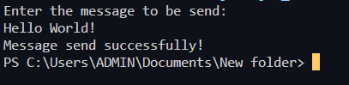

After running send.java msg.text file get create with the input message

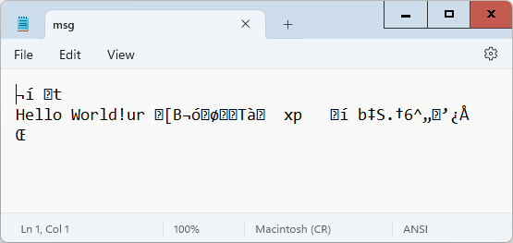

**CODE:**

**Receive.java**

import java.io.*;

import java.security.*;

public class Recieve {

public static void main(String[] args) {

byte dig[] = new byte[1024];

try {

FileInputStream fis = new FileInputStream("msg.txt");

ObjectInputStream ois = new ObjectInputStream(fis);

Object obj = ois.readObject();

String data = (String)obj;

System.out.println("Recieved Data: "+data);

obj = ois.readObject();

dig = (byte[])obj;

MessageDigest md = MessageDigest.getInstance("MD5");

md.update(data.getBytes());

if(MessageDigest.isEqual(md.digest(), dig))

System.out.println(data+" Retrieved Successfully!");

ois.close();

} catch (Exception e) {

System.out.println("Message is corrupted");

}

}

}

**OUTPUT:**



Modify the msg.txt file and run Receive.java

